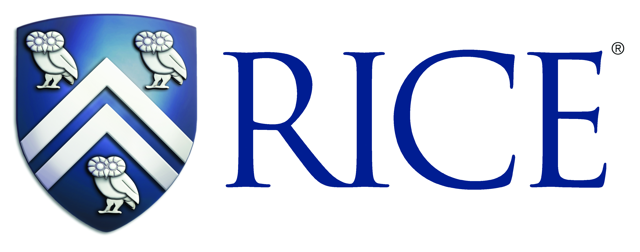

MEMORANDUM OF UNDERSTANDING

BETWEEN

INSERT Institution Name here

AND

William Marsh Rice University
(Rice University), Houston, Texas, United States of America

- Rice University and INSERT Institution Name here, in the spirit of goodwill and collaboration, hereby declare as follows:-

- Our two institutions will encourage direct contact and ties between our students, faculty and administrative staff, as well as departments, centers and related institutions; and

- Within mutually acceptable fields, the following general models of cooperation will be considered:-

- Visits by and exchange of undergraduate <optional: and graduate> students for study, research or learning opportunities;

- Visits by and exchange of faculty or staff for research, teaching and sharing opportunities;

- Joint workshops, seminars, or other mutually beneficial activities.

Our two institutions understand that this Memorandum is not intended to create binding or legal obligations on either party, except as set forth in Section 8 below. As and when details related to the above develop, such details will be set forth in agreements and terms separate and supplemental to this Memorandum.

- We both understand that financial or funding arrangements have to be discussed on a different occasion, and that any subsequent agreement will require writing separate and supplemental to this Memorandum.

- We both understand that this Memorandum will have, from time to time, supplemental annexes and attachments with regard to more specific projects.

- This Memorandum will take effect once signed below, and will remain valid for five years from the date of the last required signature.

- If before the five-year period of validity, there is need or desire for termination, such notice must be provided in writing to the other party with six (6) months’ notice.

- This Memorandum may be renewed upon mutual agreement by both parties and by way of simple declarative statements supplemental to this memorandum.

- Should on-going collaborative activities be affected by termination, the parties undertake to resolve any issue amicably by mutual agreement.

- Each party agrees to comply with all applicable laws, rules, statutes and regulations, including specifically but not limited to, export control and anti-corruption legislation, in the connection with this Memorandum. Neither party or other person acting on behalf of such party is aware of or has taken any action, directly or indirectly, that would result in a violation by such party of any applicable anti-bribery law, including but not limited to, the U.S. Foreign Corrupt Practices Act of 1977. This Memorandum is made subject to any restrictions concerning the export of products or technical information from the United States or other countries that may be imposed on the parties from time to time. Each party agrees that it will not export, directly or indirectly, any technical information acquired from the other party under this Memorandum or any products using such technical information to a location or in a manner that at the time of export requires an export license or other governmental approval, without first obtaining the written consent to do so from the appropriate agency or other governmental entity in accordance with applicable law.

<Insert Signatory and Title> |  | <Insert Signatory>  <Insert Title>  William Marsh Rice University  Houston, TX, USA
Date: |  | Date:

